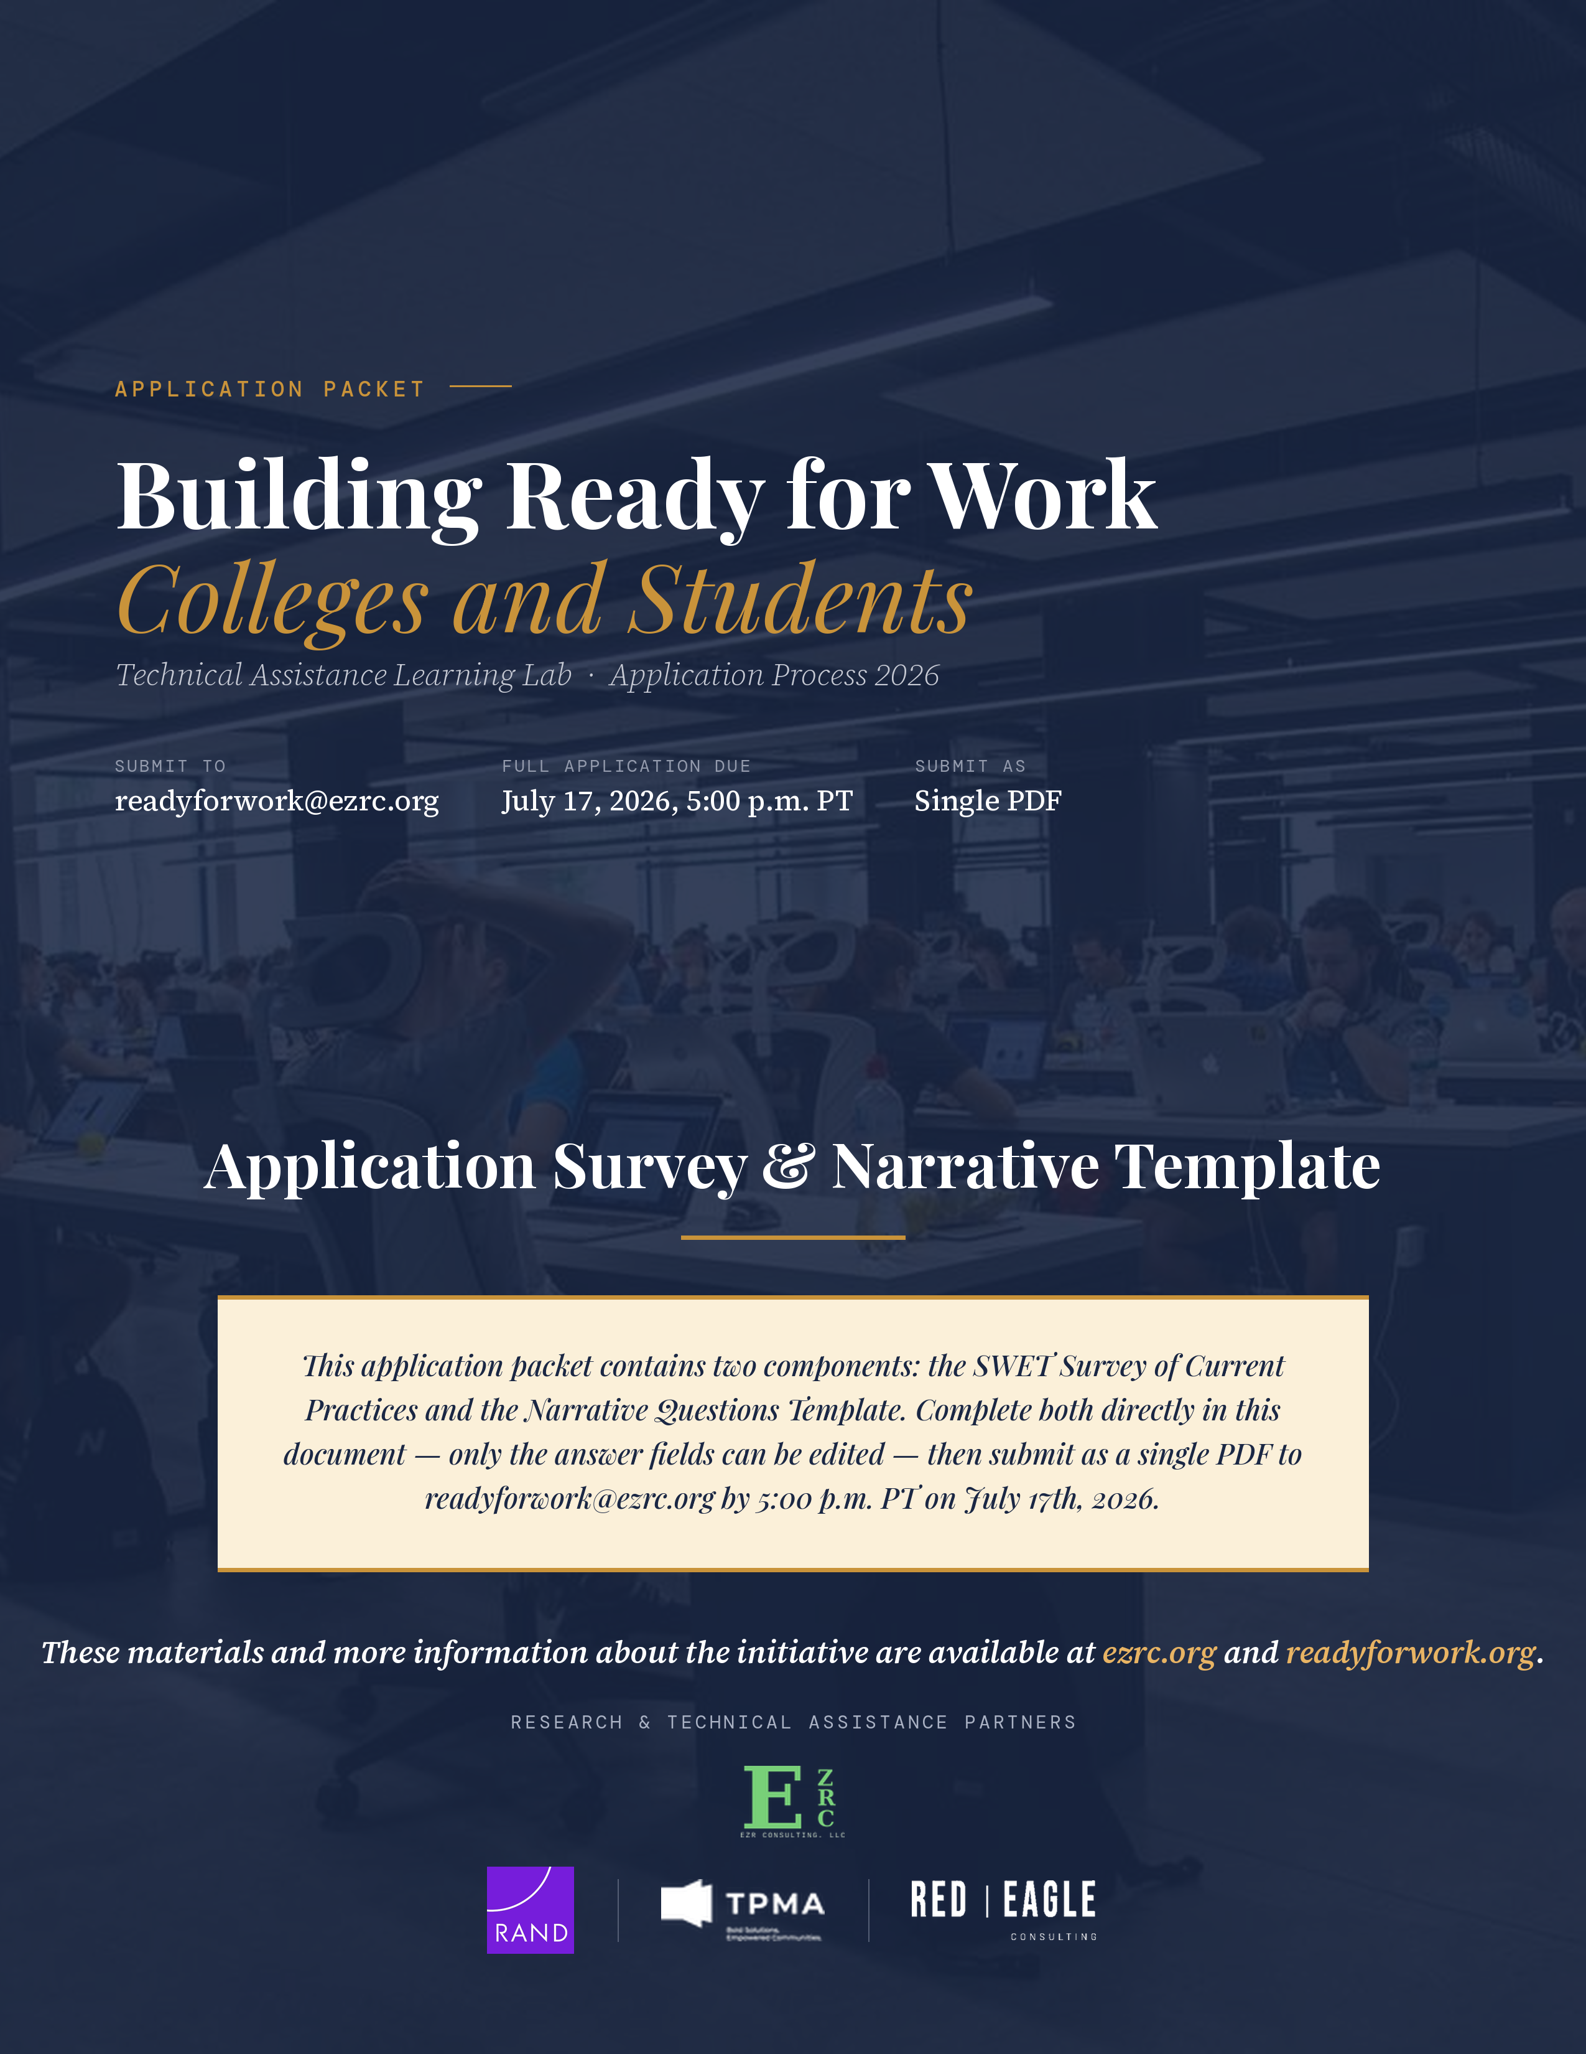

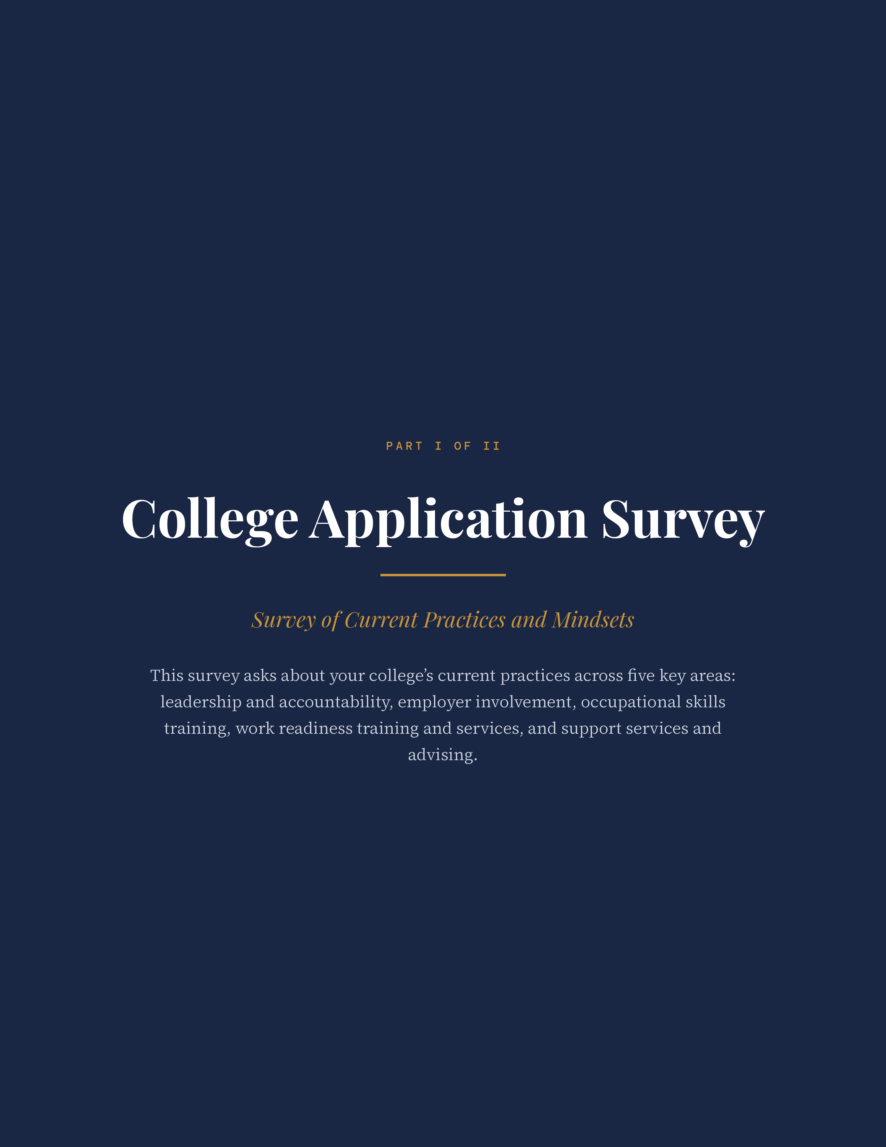
PART I · COLLEGE APPLICATION SURVEY
Building Ready for Work Colleges and Students · Page 3
Purpose and Context
Building Ready for Work Colleges and Students · Page 3

Thank you for your interest in the Building Ready for Work Colleges and Students Learning Lab. This survey is part of the college application process and asks about your college’s current practices and orientation with respect to implementing labor market-informed, employment-focused strategies that support students’ entry into high-wage, high-demand (HWHD) jobs. We are interested in your current status in five key areas: (1) Leadership and Accountability, (2) Employer Involvement, (3) Occupational Skills Training, (4) Work Readiness Training and Services, and (5) Support Services and Advising. We recognize that colleges have many strong academic services already in place; this survey is not intended to capture those practices at this time.
We anticipate that many of these practices will be in early or developing stages at most colleges, and the Learning Lab is designed precisely to serve institutions at this stage of development. We are seeking colleges that are committed to deepening and expanding these practices with structured support. There are no right or wrong answers — your honest responses will give us the baseline understanding we need to build a strong cohort and ensure that our support is well-matched to where your institution is and where it aspires to go.
Building Ready for Work Colleges and Students · Page 3
In addition to the current practices survey below, we have two additional questions at the end regarding your college’s interest in future Lab participation and activities.
Survey Instructions
Building Ready for Work Colleges and Students · Page 3

The survey items that follow are tied to key practices articulated in the Sector-Based Workforce Education and Training (SWET) framework and are organized around its five components, listed above. For each survey item, you will be asked to rate your college’s current level of implementation on a scale of 1 to 5, with 1 being little to none and 5 being fully established:
RATING | DESCRIPTION
1 — Little to None | No activity or awareness in this area
2 — Emerging | Beginning to explore; early, informal, or isolated efforts
3 — Actively Developing | Intentional work underway; building systems and capacity
4 — Largely Established | Practice is operational and consistent across most areas
5 — Fully Established | Deeply embedded; sustained, measured, and continuously improving
Building Ready for Work Colleges and Students · Page 3
Priority for Lab Work: At the top of each table, you will also be asked to rate the level of priority that topic area holds for your college’s Lab work, from 1 (highest priority) to 5 (lower priority). This helps us understand which areas your college most wants to focus on. Please check only one box for each survey item, one priority box at the top of each table, and one response in Section II.
PART I · COLLEGE APPLICATION SURVEY
Building Ready for Work Colleges and Students · Page 4
Respondent Information
Building Ready for Work Colleges and Students · Page 4

College / Institution Name | Click here to enter.
State / Region | Click here to enter.
Approximate Total Student Enrollment | Click here to enter.
Primary Contact Name and Email Address | Click here to enter.
Building Ready for Work Colleges and Students · Page 4
Project Team Members (name, title/role, and contact information for each member)
# | NAME | TITLE / ROLE | CONTACT (EMAIL)
1 | Enter name. | Enter title / role. | Enter email.
2 | Enter name. | Enter title / role. | Enter email.
3 | Enter name. | Enter title / role. | Enter email.
4 | Enter name. | Enter title / role. | Enter email.
5 | Enter name. | Enter title / role. | Enter email.
Building Ready for Work Colleges and Students · Page 4
Individuals Who Contributed to Survey and Narrative Responses (e.g., President, VP of Academic Affairs, Workforce Director, Faculty Lead). Enter each contributor’s name; title/role and contact information are needed only for individuals who are not part of the project team above.
# | NAME | TITLE / ROLE | CONTACT (EMAIL)
1 | Enter name. | Enter title / role. | Enter email.
2 | Enter name. | Enter title / role. | Enter email.
3 | Enter name. | Enter title / role. | Enter email.
4 | Enter name. | Enter title / role. | Enter email.
5 | Enter name. | Enter title / role. | Enter email.
6 | Enter name. | Enter title / role. | Enter email.
7 | Enter name. | Enter title / role. | Enter email.
8 | Enter name. | Enter title / role. | Enter email.
9 | Enter name. | Enter title / role. | Enter email.
10 | Enter name. | Enter title / role. | Enter email.
Building Ready for Work Colleges and Students · Page 4
SURVEY · SECTION 1 OF 5
Building Ready for Work Colleges and Students · Page 5
1. Leadership and Accountability
Building Ready for Work Colleges and Students · Page 5

Table 1A — Institutional Culture
PRIORITY FOR LAB WORK: ☐ 1 ☐ 2 ☐ 3 ☐ 4 ☐ 5 (1 = highest)
SURVEY ITEM | 1  Little to None | 2  Emerging | 3  Actively Developing | 4  Largely Established | 5  Fully Established
Our college has articulated a commitment to workforce training and supporting students’ direct entry into the workplace. | ☐ | ☐ | ☐ | ☐ | ☐
Our college’s mission and public communications emphasize our commitment to workforce training and employment outcomes. | ☐ | ☐ | ☐ | ☐ | ☐
College leaders (president, deans, VP-level) believe that workforce readiness and employment outcomes are a primary institutional goal. | ☐ | ☐ | ☐ | ☐ | ☐
Faculty and staff believe that workforce readiness and employment outcomes are a primary institutional goal. | ☐ | ☐ | ☐ | ☐ | ☐
College leaders view employers as key clients of the college’s services. | ☐ | ☐ | ☐ | ☐ | ☐
Faculty and staff view employers as key clients of the college’s services. | ☐ | ☐ | ☐ | ☐ | ☐
College leaders can articulate our specific commitment to workforce training. | ☐ | ☐ | ☐ | ☐ | ☐
Faculty and staff can articulate our specific commitment to workforce training. | ☐ | ☐ | ☐ | ☐ | ☐
Building Ready for Work Colleges and Students · Page 5
Table 1B — Awareness of Employer and Labor Market Needs
PRIORITY FOR LAB WORK: ☐ 1 ☐ 2 ☐ 3 ☐ 4 ☐ 5 (1 = highest)
SURVEY ITEM | 1  Little to None | 2  Emerging | 3  Actively Developing | 4  Largely Established | 5  Fully Established
Our college leaders are aware of evidence/research showing a gap between the skills employers seek and the skills of recent college graduates. | ☐ | ☐ | ☐ | ☐ | ☐
Faculty and staff are aware of evidence/research showing a gap between the skills employers seek and the skills of recent college graduates. | ☐ | ☐ | ☐ | ☐ | ☐
College leaders can articulate how our college’s programs align with employer and local labor market needs. | ☐ | ☐ | ☐ | ☐ | ☐
Faculty and staff can articulate how our college’s programs align with employer and local labor market needs. | ☐ | ☐ | ☐ | ☐ | ☐
College leaders are aware of the durable/workplace readiness/non-technical skills that employers seek. | ☐ | ☐ | ☐ | ☐ | ☐
Faculty and staff are aware of the durable/workplace readiness/non-technical skills that employers seek. | ☐ | ☐ | ☐ | ☐ | ☐
Building Ready for Work Colleges and Students · Page 6
Table 1C — Data, Metrics, and Accountability
PRIORITY FOR LAB WORK: ☐ 1 ☐ 2 ☐ 3 ☐ 4 ☐ 5 (1 = highest)
SURVEY ITEM | 1  Little to None | 2  Emerging | 3  Actively Developing | 4  Largely Established | 5  Fully Established
Our college collects and uses labor market data (e.g., job demand, emerging skills, regional trends) to inform programming. | ☐ | ☐ | ☐ | ☐ | ☐
We verify the accuracy of labor market data through direct employer or industry input. | ☐ | ☐ | ☐ | ☐ | ☐
Labor market data is reviewed and shared with faculty and program staff. | ☐ | ☐ | ☐ | ☐ | ☐
Our college has metrics to assess how well our programs and curricula are aligned with employer and local labor needs. | ☐ | ☐ | ☐ | ☐ | ☐
Our college has access to or collects data on students’/graduates’ employment and earnings. | ☐ | ☐ | ☐ | ☐ | ☐
Our college has metrics to define and assess students’ workplace readiness/durable skills. | ☐ | ☐ | ☐ | ☐ | ☐
The workplace readiness metrics our college uses are informed by employers’ needs. | ☐ | ☐ | ☐ | ☐ | ☐
Our college collects feedback from employers about our programming and graduates. | ☐ | ☐ | ☐ | ☐ | ☐
Our college has established systems to review, add, or sunset programs or courses based on current workforce needs. | ☐ | ☐ | ☐ | ☐ | ☐
Building Ready for Work Colleges and Students · Page 6
SURVEY · SECTION 2 OF 5
Building Ready for Work Colleges and Students · Page 7
2. Employer Involvement
Building Ready for Work Colleges and Students · Page 7

Table 2A — Management of Employer Relationships
PRIORITY FOR LAB WORK: ☐ 1 ☐ 2 ☐ 3 ☐ 4 ☐ 5 (1 = highest)
SURVEY ITEM | 1  Little to None | 2  Emerging | 3  Actively Developing | 4  Largely Established | 5  Fully Established
Our college has staff dedicated to cultivating and managing employer and industry relationships. | ☐ | ☐ | ☐ | ☐ | ☐
Staff managing employer relationships have meaningful prior industry or employer-facing experience. | ☐ | ☐ | ☐ | ☐ | ☐
Faculty and staff know who manages our employer relationships. | ☐ | ☐ | ☐ | ☐ | ☐
Faculty and staff regularly engage with the staff who manage our employer relationships. | ☐ | ☐ | ☐ | ☐ | ☐
Employers know who to contact at our college to discuss their interests and needs. | ☐ | ☐ | ☐ | ☐ | ☐
Building Ready for Work Colleges and Students · Page 7
Table 2B — Employer Engagement and Investment
PRIORITY FOR LAB WORK: ☐ 1 ☐ 2 ☐ 3 ☐ 4 ☐ 5 (1 = highest)
SURVEY ITEM | 1  Little to None | 2  Emerging | 3  Actively Developing | 4  Largely Established | 5  Fully Established
Our college participates in industry collaboratives or workforce-focused groups to discuss local labor market needs. | ☐ | ☐ | ☐ | ☐ | ☐
College leaders (president, deans, VP-level) have strong relationships with multiple employers. | ☐ | ☐ | ☐ | ☐ | ☐
College faculty and staff have strong relationships with employers. | ☐ | ☐ | ☐ | ☐ | ☐
Our college regularly reaches out to employers to discuss their interests and needs. | ☐ | ☐ | ☐ | ☐ | ☐
Employers regularly reach out to our college to discuss their interests and needs. | ☐ | ☐ | ☐ | ☐ | ☐
Employers signal that they value the relationship with the college by sustaining engagement over multiple years. | ☐ | ☐ | ☐ | ☐ | ☐
Employers invest in our college (financial support, equipment donations). | ☐ | ☐ | ☐ | ☐ | ☐
Employers have made a commitment to hire our graduates. | ☐ | ☐ | ☐ | ☐ | ☐
Our college has made commitments to employers that our graduates will be job-ready. | ☐ | ☐ | ☐ | ☐ | ☐
Building Ready for Work Colleges and Students · Page 8
Table 2C — Employer Input into Curriculum and Programming
PRIORITY FOR LAB WORK: ☐ 1 ☐ 2 ☐ 3 ☐ 4 ☐ 5 (1 = highest)
SURVEY ITEM | 1  Little to None | 2  Emerging | 3  Actively Developing | 4  Largely Established | 5  Fully Established
Our programs have active advisory boards that include employer or industry representatives. | ☐ | ☐ | ☐ | ☐ | ☐
Our advisory boards meet regularly (more than once a year) to review and provide input on curricula or programming. | ☐ | ☐ | ☐ | ☐ | ☐
Employers provide input on our curriculum and programming. | ☐ | ☐ | ☐ | ☐ | ☐
Our curriculum and programs are revised in response to employers’ input. | ☐ | ☐ | ☐ | ☐ | ☐
Faculty align their instruction to sector-specific work readiness skills employers seek. | ☐ | ☐ | ☐ | ☐ | ☐
Building Ready for Work Colleges and Students · Page 8
Table 2D — Employer Interactions with Students
PRIORITY FOR LAB WORK: ☐ 1 ☐ 2 ☐ 3 ☐ 4 ☐ 5 (1 = highest)
SURVEY ITEM | 1  Little to None | 2  Emerging | 3  Actively Developing | 4  Largely Established | 5  Fully Established
Employers interact with students at our college about employment (e.g., job fairs, company showcases). | ☐ | ☐ | ☐ | ☐ | ☐
Employers provide supports for students’ job search (e.g., mock interviews, resume review, office tours). | ☐ | ☐ | ☐ | ☐ | ☐
Employers provide our students with work-based learning opportunities (e.g., internships, externships, job shadowing). | ☐ | ☐ | ☐ | ☐ | ☐
Employers provide financial supports to our students (e.g., wages, scholarships, stipends). | ☐ | ☐ | ☐ | ☐ | ☐
Our college has policies or practices to ensure that students interact with employers. | ☐ | ☐ | ☐ | ☐ | ☐
Work-based learning (WBL) opportunities are available and structured for students. | ☐ | ☐ | ☐ | ☐ | ☐
Students access and regularly participate in work-based learning opportunities. | ☐ | ☐ | ☐ | ☐ | ☐
Building Ready for Work Colleges and Students · Page 9
SURVEY · SECTION 3 OF 5
Building Ready for Work Colleges and Students · Page 9
3. Occupational Skills Training
Building Ready for Work Colleges and Students · Page 9

Table 3A — Program Review, Revision, and Labor Market Alignment
PRIORITY FOR LAB WORK: ☐ 1 ☐ 2 ☐ 3 ☐ 4 ☐ 5 (1 = highest)
SURVEY ITEM | 1  Little to None | 2  Emerging | 3  Actively Developing | 4  Largely Established | 5  Fully Established
Programs and curriculum are designed based on current labor market and employer needs. | ☐ | ☐ | ☐ | ☐ | ☐
Programs are regularly reviewed and updated to maintain alignment with labor market needs. | ☐ | ☐ | ☐ | ☐ | ☐
Learning objectives in courses directly reflect skills found in relevant job postings. | ☐ | ☐ | ☐ | ☐ | ☐
Building Ready for Work Colleges and Students · Page 9
Table 3B — Pathways to High-Wage, High-Demand Jobs
PRIORITY FOR LAB WORK: ☐ 1 ☐ 2 ☐ 3 ☐ 4 ☐ 5 (1 = highest)
SURVEY ITEM | 1  Little to None | 2  Emerging | 3  Actively Developing | 4  Largely Established | 5  Fully Established
Our college has a shared, working definition of high-wage, high-demand (HWHD) jobs. | ☐ | ☐ | ☐ | ☐ | ☐
Development of training pathways leading to HWHD employment is an institutional priority. | ☐ | ☐ | ☐ | ☐ | ☐
Faculty and staff can explain how their programs connect to HWHD job entry. | ☐ | ☐ | ☐ | ☐ | ☐
Our students are in training and education pathways that lead to HWHD jobs. | ☐ | ☐ | ☐ | ☐ | ☐
Building Ready for Work Colleges and Students · Page 9
Table 3C — Flexible Pathways and Credentials
PRIORITY FOR LAB WORK: ☐ 1 ☐ 2 ☐ 3 ☐ 4 ☐ 5 (1 = highest)
SURVEY ITEM | 1  Little to None | 2  Emerging | 3  Actively Developing | 4  Largely Established | 5  Fully Established
Our college prioritizes pathways with multiple entry and exit points and stackable credentials to support employment entry and advancement. | ☐ | ☐ | ☐ | ☐ | ☐
We have verified the utility of the credentials we provide with employers or industry leaders. | ☐ | ☐ | ☐ | ☐ | ☐
Flexible, short-term, or non-credit options are used to respond quickly to employer needs. | ☐ | ☐ | ☐ | ☐ | ☐
Systems exist to award credit for prior learning, non-credit coursework, or industry credentials. | ☐ | ☐ | ☐ | ☐ | ☐
Building Ready for Work Colleges and Students · Page 10
SURVEY · SECTION 4 OF 5
Building Ready for Work Colleges and Students · Page 10
4. Work Readiness Training and Services
Building Ready for Work Colleges and Students · Page 10

Table 4A — Workplace Readiness / Durable Skills Development
PRIORITY FOR LAB WORK: ☐ 1 ☐ 2 ☐ 3 ☐ 4 ☐ 5 (1 = highest)
SURVEY ITEM | 1  Little to None | 2  Emerging | 3  Actively Developing | 4  Largely Established | 5  Fully Established
Our college provides explicit instruction and coaching in durable/workplace readiness skills. | ☐ | ☐ | ☐ | ☐ | ☐
Durable skills instruction is embedded across programs — not limited to one course or office. | ☐ | ☐ | ☐ | ☐ | ☐
Students can identify and articulate the specific workplace skills that employers seek. | ☐ | ☐ | ☐ | ☐ | ☐
Students learn from and demonstrate workplace readiness skills with their peers. | ☐ | ☐ | ☐ | ☐ | ☐
Students demonstrate workplace readiness skills as part of their education and training. | ☐ | ☐ | ☐ | ☐ | ☐
Methods exist to evaluate students’ mastery of workplace readiness skills. | ☐ | ☐ | ☐ | ☐ | ☐
Accountability structures exist that support students’ understanding of unacceptable workplace behaviors (e.g., consequences for tardiness, lack of professionalism). | ☐ | ☐ | ☐ | ☐ | ☐
Students’ workplace readiness skill attainment is documented and visible to employers. | ☐ | ☐ | ☐ | ☐ | ☐
Building Ready for Work Colleges and Students · Page 11
Table 4B — Job Search and Career Supports
PRIORITY FOR LAB WORK: ☐ 1 ☐ 2 ☐ 3 ☐ 4 ☐ 5 (1 = highest)
SURVEY ITEM | 1  Little to None | 2  Emerging | 3  Actively Developing | 4  Largely Established | 5  Fully Established
A comprehensive range of career services is available to students (resume review, mock interviews, job databases, etc.). | ☐ | ☐ | ☐ | ☐ | ☐
Career and job search supports are integrated into curriculum — not siloed in a single office. | ☐ | ☐ | ☐ | ☐ | ☐
Multiple staff (career services, faculty, advisors, employers) actively support students’ job searches. | ☐ | ☐ | ☐ | ☐ | ☐
Building Ready for Work Colleges and Students · Page 11
SURVEY · SECTION 5 OF 5
Building Ready for Work Colleges and Students · Page 11
5. Support Services and Advising
Building Ready for Work Colleges and Students · Page 11

Table 5A — Assessment of Needs and Case Management / Coaching
PRIORITY FOR LAB WORK: ☐ 1 ☐ 2 ☐ 3 ☐ 4 ☐ 5 (1 = highest)
SURVEY ITEM | 1  Little to None | 2  Emerging | 3  Actively Developing | 4  Largely Established | 5  Fully Established
Our college uses systematic tools to assess students’ holistic (non-academic) needs. | ☐ | ☐ | ☐ | ☐ | ☐
Tailored support plans are developed based on students’ identified needs. | ☐ | ☐ | ☐ | ☐ | ☐
Coaches or case managers actively help students identify and access available services. | ☐ | ☐ | ☐ | ☐ | ☐
Building Ready for Work Colleges and Students · Page 11
Table 5B — Holistic Supports
PRIORITY FOR LAB WORK: ☐ 1 ☐ 2 ☐ 3 ☐ 4 ☐ 5 (1 = highest)
SURVEY ITEM | 1  Little to None | 2  Emerging | 3  Actively Developing | 4  Largely Established | 5  Fully Established
Services are available to meet students’ basic needs (food, transportation, childcare, housing). | ☐ | ☐ | ☐ | ☐ | ☐
Counseling and mental health supports are available and accessible to students. | ☐ | ☐ | ☐ | ☐ | ☐
Building Ready for Work Colleges and Students · Page 12
Table 5C — Financial Supports
PRIORITY FOR LAB WORK: ☐ 1 ☐ 2 ☐ 3 ☐ 4 ☐ 5 (1 = highest)
SURVEY ITEM | 1  Little to None | 2  Emerging | 3  Actively Developing | 4  Largely Established | 5  Fully Established
Financial supports (stipends, Pell, WBL compensation) are available during training. | ☐ | ☐ | ☐ | ☐ | ☐
Students are financially compensated in ways that mirror employment structures and pay (e.g., paychecks, stipends, accountability for performance). | ☐ | ☐ | ☐ | ☐ | ☐
Financial supports are tied to accountability for workplace norms and performance expectations. | ☐ | ☐ | ☐ | ☐ | ☐
Building Ready for Work Colleges and Students · Page 12
Table 5D — Post-Completion Follow-Up
PRIORITY FOR LAB WORK: ☐ 1 ☐ 2 ☐ 3 ☐ 4 ☐ 5 (1 = highest)
SURVEY ITEM | 1  Little to None | 2  Emerging | 3  Actively Developing | 4  Largely Established | 5  Fully Established
Our college tracks students’ employment outcomes after program completion. | ☐ | ☐ | ☐ | ☐ | ☐
Our college has systems to support and follow up with students after graduation. | ☐ | ☐ | ☐ | ☐ | ☐
Building Ready for Work Colleges and Students · Page 12
SURVEY · ADDITIONAL QUESTIONS
Building Ready for Work Colleges and Students · Page 12
Section II. Interest in Sharing Student-Level Data
Building Ready for Work Colleges and Students · Page 12

Please indicate whether your college is interested in sharing de-identified student-level data for a deeper analysis. Colleges that share student-level data will receive a $30,000 stipend to support their work with the research team.
☐ Yes, we are interested ☐ No, we are not interested ☐ Unsure at this time
Building Ready for Work Colleges and Students · Page 12
Section III. Future Consideration for Lab Participation and Services
Building Ready for Work Colleges and Students · Page 13

The number of colleges selected for the Learning Lab will be limited to 7–8 colleges due to funding constraints. However, there may be future opportunities to participate in the Lab or in specific Lab activities. Please indicate your interest in participating should additional funding become available.
Please check all that apply:
☐ Full Learning Lab participation
☐ Coaching
☐ Community of Practice (CoP)
☐ Webinars
☐ Individual consulting
Thank you for completing this survey. Your responses will help us understand your college’s current practices and priorities, and inform the selection and design of the Ready for Work Learning Lab cohort.
Building Ready for Work Colleges and Students · Page 13
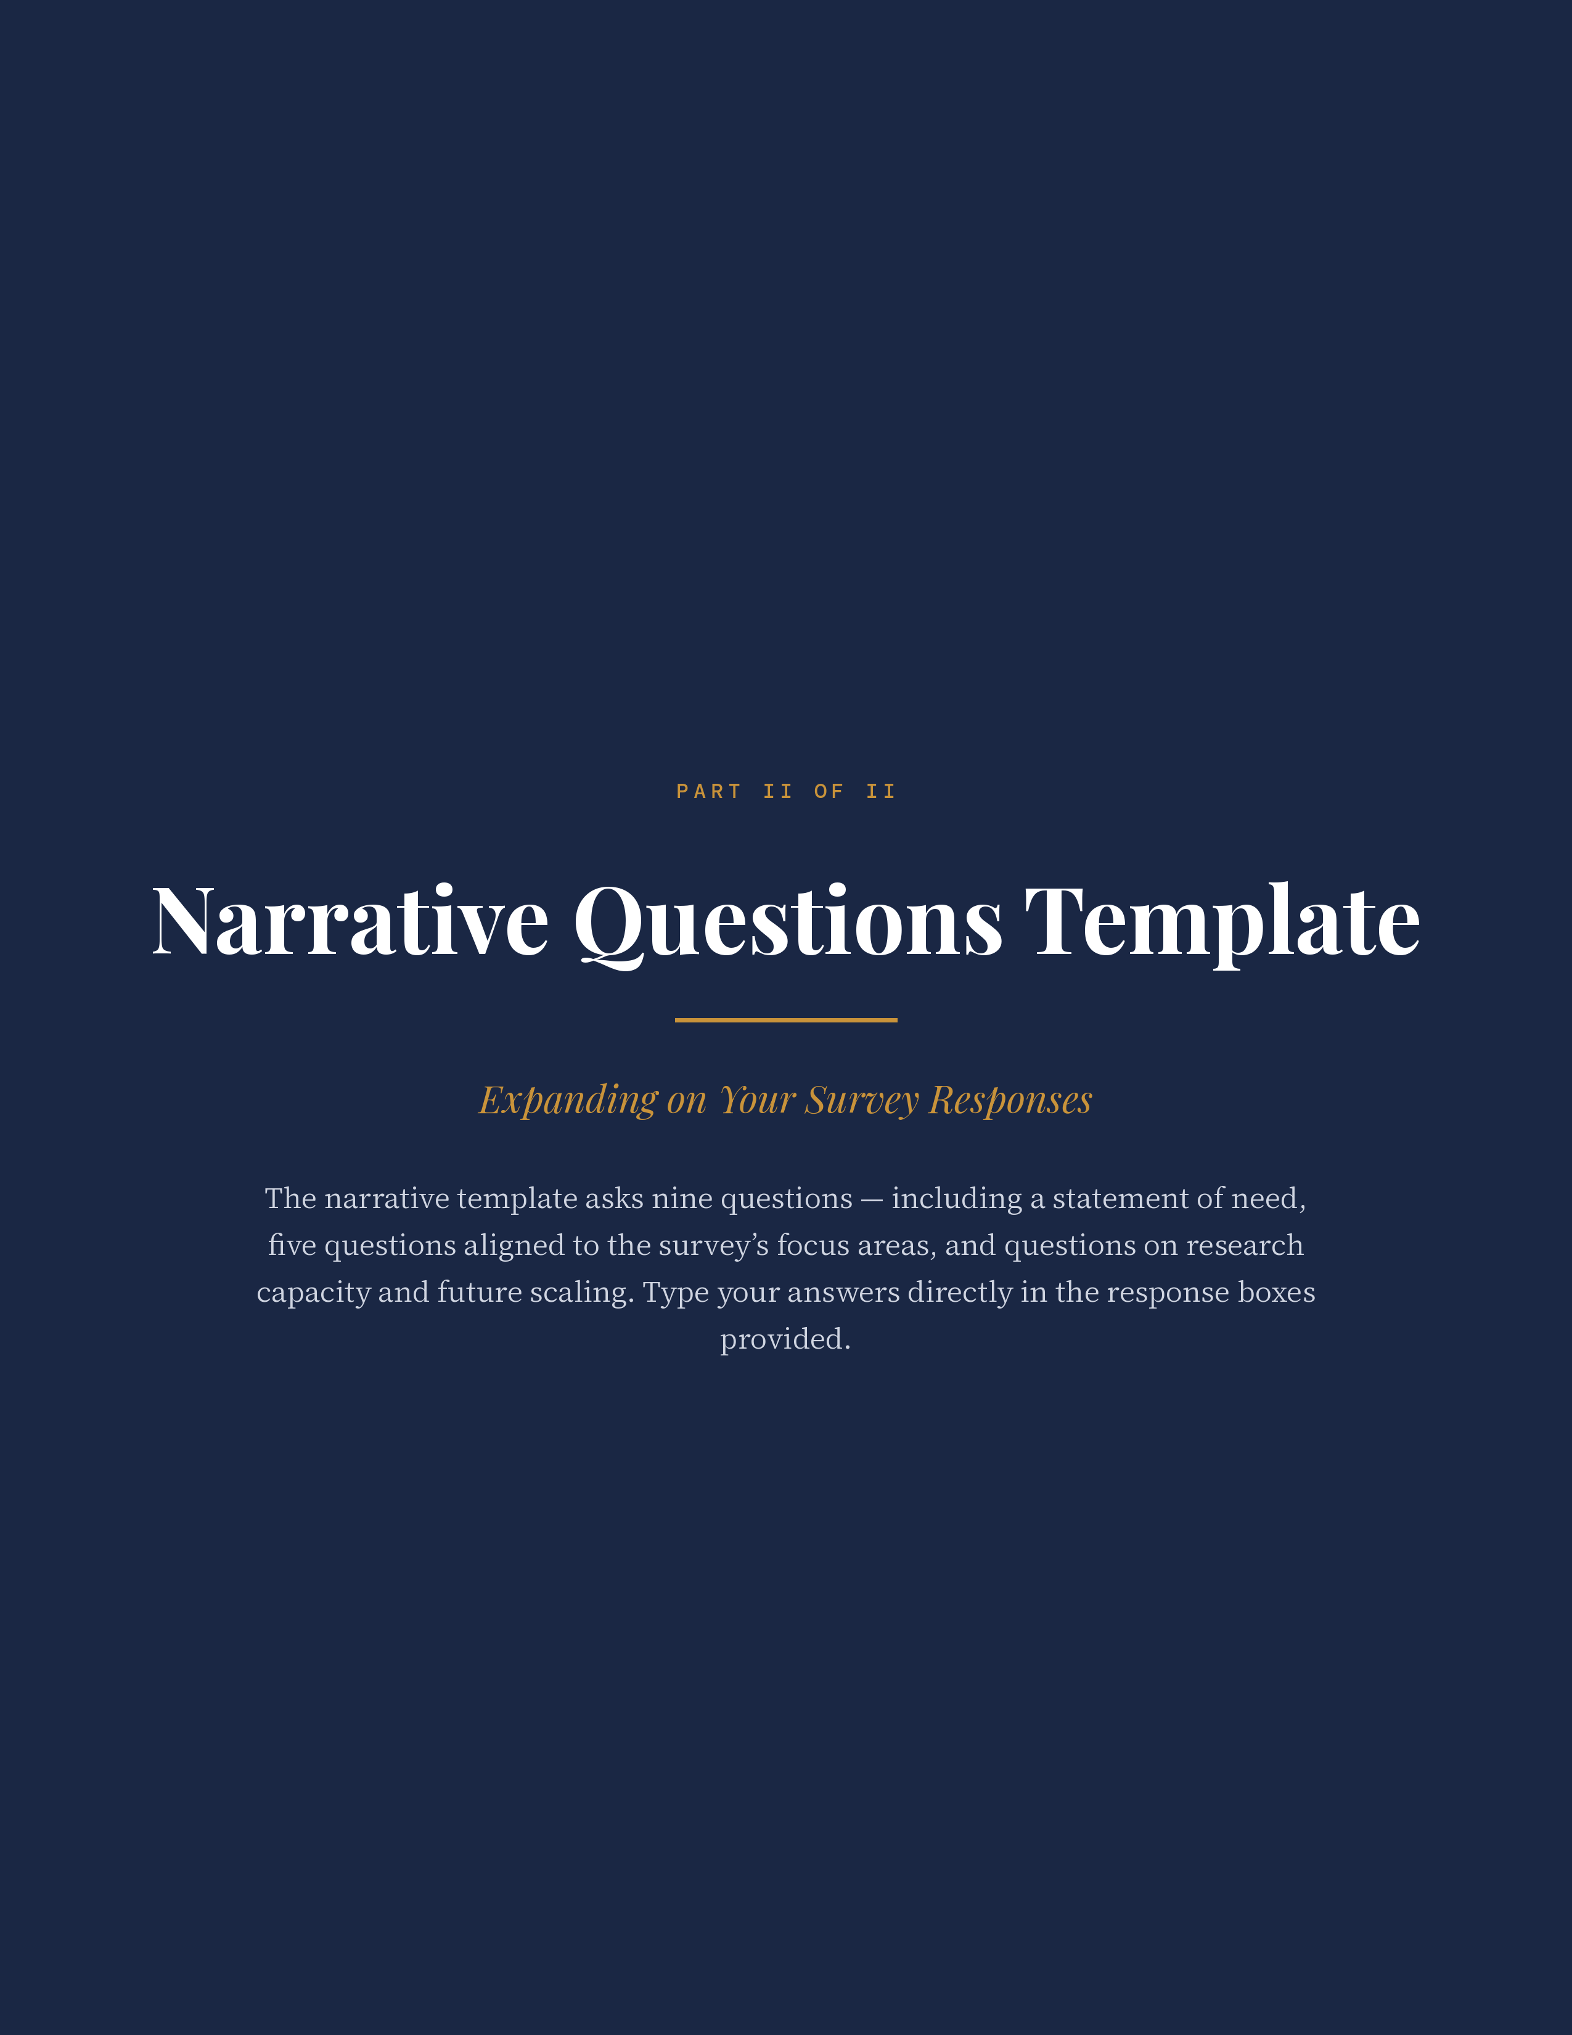
PART II · NARRATIVE QUESTIONS TEMPLATE
Building Ready for Work Colleges and Students · Page 15
About This Template
Building Ready for Work Colleges and Students · Page 15

This document provides a template for applying to the Ready for Work Learning Lab. Please also refer to the Overview document for background on the Lab, partner organizations, services, eligibility requirements, and key dates.
Before completing this narrative template, please complete the Sector-Based Workforce Education and Training (SWET) survey in Part I. This narrative template provides an opportunity to expand on your survey responses.
Please email completed applications as a single PDF to readyforwork@ezrc.org. Applications are reviewed on a rolling basis.
Building Ready for Work Colleges and Students · Page 15
What to Include in Your Application
Building Ready for Work Colleges and Students · Page 15

— Cover sheet — college name and address; project lead and project team (name, department, title, and contact information for each member); and institutional research department contact.
— Completion of the SWET survey — Part I of this package.
— Narrative questions — the nine questions that follow.
Narrative Questions
Building Ready for Work Colleges and Students · Page 15

Please respond to the narrative questions below. Questions 2–6 align with the five sections of the survey and allow you to further expand on your answers. In addition, we ask you to provide information on your research capacity and thoughts on future scaling of SWET-aligned practices. Please try to limit your responses as closely as possible to the word counts indicated for each question. Information on how applications will be reviewed is provided in the overview and instructions document.
QUESTION 1 · UP TO 500 WORDS
Building Ready for Work Colleges and Students · Page 15
Statement of Need
Building Ready for Work Colleges and Students · Page 15
Provide an overview of your college’s needs and interests for participating in the Ready for Work Learning Lab. Please highlight:
— 2–3 high-priority sectors that offer high-wage, high-demand jobs in your region and your current practices with respect to these areas (e.g., healthcare, IT, advanced manufacturing).
— 2–3 priority areas for growth and what your team hopes to accomplish over the next two years (e.g., new employer partnerships, redesigned pathways, expanded work-based learning, improved data tracking).
— How the Lab will support your college: discuss the key benefits or supports you believe the Lab could provide and why participation is important to your college.
YOUR RESPONSE
Building Ready for Work Colleges and Students · Page 16
Begin typing your response here. Recommended length: 500 words or fewer.
Building Ready for Work Colleges and Students · Page 16
QUESTION 2 · UP TO 500 WORDS
Building Ready for Work Colleges and Students · Page 16
Leadership and Accountability
Building Ready for Work Colleges and Students · Page 16
Provide an overview of how your college will lead this work, who will be involved, and how you will seek to drive institutional change around SWET-aligned practices. Please discuss executive-level leadership commitment to the work and provide a letter of commitment from executive-level leadership in an attachment. Describe the team leaders that will be primarily responsible for the work and include short biographies (2–5 sentences) for each team member along with statements of commitment and availability for Lab activities. Discuss your institution’s current orientation to workforce training; what would help or get in the way of implementing workforce- and employment-oriented mindsets and practices; and strategies or supports that the Lab might provide to help with these institutional changes.
REQUIRED ATTACHMENT · Letter of commitment from executive-level leadership.
REQUIRED ATTACHMENT · Statements of commitment and availability from team members with short biographies.
QUESTIONS FOR REFLECTION
Building Ready for Work Colleges and Students · Page 16
How strong is executive-level leadership commitment to this work? In what ways, if any, may executive leaders support faculty and staff in carrying out the work?
Who will lead this work and how do their roles help support future growth and implementation?
How will your Lab leadership team drive and sustain an institutional culture focused on work readiness?
What supports would be most helpful in building your institution’s workforce orientation?
YOUR RESPONSE
Building Ready for Work Colleges and Students · Page 16
Begin typing your response here. Recommended length: 500 words or fewer.
Building Ready for Work Colleges and Students · Page 16
QUESTION 3 · UP TO 500 WORDS
Building Ready for Work Colleges and Students · Page 17
Employer Involvement
Building Ready for Work Colleges and Students · Page 17
Please discuss your current level of engagement with employers and how you hope to further strengthen these relationships as part of the Lab. Discuss your current practices and growth areas in relation to managing employer engagement; employers’ input into curriculum and programming; connections employers have with staff or students; and metrics you use to track the quality of your relationships with employers. As is relevant, discuss supports and services that the Lab could provide in helping you further develop or strengthen these connections and metrics.
OPTIONAL ATTACHMENT · Attach a letter of commitment from employer(s) stating their interest in working with the college as part of their Lab work.
QUESTIONS FOR REFLECTION
Building Ready for Work Colleges and Students · Page 17
Who is responsible for employer engagement, and in what ways, if any, are they attuned to the language and needs of employers or the industry?
What influence, if any, do employers have on the college’s programming and curricula? How do you know if their input is being integrated into the college’s work?
How, if at all, do employers interface with faculty, staff, or students? What role do employers play in helping students learn about workplace skills and expectations?
How, if at all, do you track the quality and quantity of employer interactions?
YOUR RESPONSE
Building Ready for Work Colleges and Students · Page 17
Begin typing your response here. Recommended length: 500 words or fewer.
Building Ready for Work Colleges and Students · Page 17
QUESTION 4 · UP TO 500 WORDS
Building Ready for Work Colleges and Students · Page 17
Occupational Skills Training
Building Ready for Work Colleges and Students · Page 17
Provide a brief overview of your college’s current sectoral training pathways, their average enrollments, and their scale relative to the college’s overall enrollment, as well as your interests for growth as part of the Lab. Discuss your current practices and areas for growth with respect to your programs’ alignment with employer and labor market needs; the prioritization of high-wage, high-demand jobs; and the alternative ways that students can enter and exit these programs with credentials of value to employers. As is relevant, discuss supports and services that the Lab could provide in helping you further develop or strengthen your college’s occupational training.
OPTIONAL ATTACHMENT · Attach a table or appendix summarizing your college’s current sector pathways, enrollment, and scale.
QUESTIONS FOR REFLECTION
Building Ready for Work Colleges and Students · Page 17
How does the occupational skills training provided align with employer and labor market needs? How do you measure this alignment?
How, if at all, does your college prioritize programming in relation to high- versus lower-wage jobs?
What entry and exit points exist within your college’s training pathways? How, if at all, do the credentials provided align with skills needed for entry into the labor force?
How, if at all, do your current pathways allow for alternative training options (e.g., credit for prior learning, non-credit to credit articulation, Workforce Pell-eligibility)?
YOUR RESPONSE
Building Ready for Work Colleges and Students · Page 18
Begin typing your response here. Recommended length: 500 words or fewer.
Building Ready for Work Colleges and Students · Page 18
QUESTION 5 · UP TO 500 WORDS
Building Ready for Work Colleges and Students · Page 18
Work Readiness Training and Services
Building Ready for Work Colleges and Students · Page 18
Please describe the services and supports your college currently provides to build students’ workplace readiness skills and how you would like to strengthen these services during the Lab. Discuss whether and how your college defines and measures students’ workplace readiness; the depth and reach of services provided; whether and how students demonstrate these skills; and the supports your college provides for students’ job search. As is relevant, discuss supports and services that the Lab could provide in helping you further develop or strengthen these services.
QUESTIONS FOR REFLECTION
Building Ready for Work Colleges and Students · Page 18
How, if at all, does your college define durable workplace readiness skills? Who knows and can articulate these skills?
How do students learn about the workplace expectations, norms, and behaviors that employers expect?
In what ways, if any, are students asked to demonstrate workplace readiness skills? How, if at all, does your college assess and communicate these skills to potential employers?
Are services such as resume development, interview preparation, job identification, or employer interactions available at your college? What capacity does your college have to provide these services?
YOUR RESPONSE
Building Ready for Work Colleges and Students · Page 18
Begin typing your response here. Recommended length: 500 words or fewer.
Building Ready for Work Colleges and Students · Page 18
QUESTION 6 · UP TO 500 WORDS
Building Ready for Work Colleges and Students · Page 19
Support Services and Advising
Building Ready for Work Colleges and Students · Page 19
We anticipate that most colleges will have a wide variety of student support services available, such as tutoring, advising, student orientation courses, etc. In this section, please consider if and how these services are directed toward or support students’ future employment, and what capacities you would be interested in further strengthening and developing as part of the Lab. Discuss whether your college already has or has an interest in developing a process for understanding students’ full range of needs; direct guidance to help students access and use supports; and whether and how supports such as financial assistance, peer learning, and post-completion services advance students’ work readiness and employment. As is relevant, discuss supports and services that the Lab could provide in helping you further develop or strengthen these services.
QUESTIONS FOR REFLECTION
Building Ready for Work Colleges and Students · Page 19
How, if at all, do you assess students’ holistic needs and develop plans to meet them?
How much direct guidance does your college provide to help students access these supports?
How, if at all, do peer networks or peer-to-peer learning support students’ understanding of workplace norms and behaviors?
What strategies does your college employ to ensure students obtain, maintain, and/or advance in their employment after completing their program?
YOUR RESPONSE
Building Ready for Work Colleges and Students · Page 19
Begin typing your response here. Recommended length: 500 words or fewer.
Building Ready for Work Colleges and Students · Page 19
QUESTION 7 · UP TO 250 WORDS
Building Ready for Work Colleges and Students · Page 19
Potential for Future Growth and Scaling
Building Ready for Work Colleges and Students · Page 19
We recognize that two years is a short timeframe for implementing SWET-aligned practices, and that sustained growth will require time beyond the Lab. Please describe your thoughts on how the mindsets and practices you develop as part of the Lab can be grown and scaled after its completion. Discuss any potential ways the Lab can support you in this expansion.
QUESTIONS FOR REFLECTION
Building Ready for Work Colleges and Students · Page 19
How, if at all, can the mindsets, practices, and services developed in the Lab be applied to other programs and majors at your college?
What types of resources will be needed to ensure that Lab mindsets, practices, and services are sustainable?
YOUR RESPONSE
Building Ready for Work Colleges and Students · Page 20
Begin typing your response here. Recommended length: 250 words or fewer.
Building Ready for Work Colleges and Students · Page 20
QUESTION 8 · UP TO 500 WORDS
Building Ready for Work Colleges and Students · Page 20
Research Capacity
Building Ready for Work Colleges and Students · Page 20
A central part of the Lab’s work will be to explore new ways to capture employment- and workforce-oriented information and track enrollments and outcomes in sector-focused programs. Please describe your institution’s ability to and interest in participating in both internal research development and in the external research study. Describe your institution’s capacity to participate in the research and potential challenges; data availability; current tracking (if any) of students’ employment and earnings; and areas for growth. Indicate whether you are interested in sharing de-identified student-level data for a deeper analysis — colleges that do so will receive a $30,000 stipend to support their work with the research team. Please provide a statement of commitment from your IR lead communicating their interest in and commitment to both internal and external research development.
REQUIRED ATTACHMENT · Statement of interest and commitment from IR lead.
QUESTIONS FOR REFLECTION
Building Ready for Work Colleges and Students · Page 20
How much do college leaders know about data that can be used to track students’ employment and earnings?
What access does your college have to employment and earnings data?
What Lab services or supports could help your college in accessing and analyzing labor market data?
Describe your current data capacity, potential barriers to sharing, and strategies for overcoming those challenges.
Does your college have the infrastructure that would support the sharing of de-identified student-level data?
Select one response: Select If other: Click to explain.
Building Ready for Work Colleges and Students · Page 20
Please indicate whether your college is interested in sharing de-identified student-level data for a deeper analysis. Colleges that share student-level data will receive a $30,000 stipend to support their work with the research team. (Also asked on the survey.)
Select one response: Select
Building Ready for Work Colleges and Students · Page 20
YOUR RESPONSE
Building Ready for Work Colleges and Students · Page 21
Begin typing your response here. Recommended length: 500 words or fewer.
Building Ready for Work Colleges and Students · Page 21
QUESTION 9 · UP TO 250 WORDS
Building Ready for Work Colleges and Students · Page 21
Unique Contributions from Your College (Optional)
Building Ready for Work Colleges and Students · Page 21
Describe any ways that you think your college will make a unique contribution to the Lab and community of practice. Discussion could emphasize (but is not limited to) geographic diversity, rural location, institution size, unique sectors of focus, and/or strength of employer commitment.
YOUR RESPONSE
Building Ready for Work Colleges and Students · Page 21
Begin typing your response here. Recommended length: 250 words or fewer.
Building Ready for Work Colleges and Students · Page 21
Required Attachments
Building Ready for Work Colleges and Students · Page 21

— Letter of commitment from college president: A brief letter confirming the college’s intent to participate for the full two-year Learning Lab period, commitment to implementing SWET-aligned practices and mindsets, and support for the designated project team (e.g., time, coordination, and participation in coaching and convenings).
— Letter of commitment and availability from team members with short biographies: Short (2–5 sentences) biographies for each team member, statements of commitment to the work, and confirmation of availability for Lab activities.
— Letter of commitment from IR lead: A short letter describing your institution’s interest in and commitment to participating in both internal and external research activities.
Optional Attachments
Building Ready for Work Colleges and Students · Page 22

— Letter of support from employer partner(s): A brief letter indicating the employer’s commitment to working with your college during the Learning Lab and to providing input for internal and external research (e.g., input on program design, participation in work-based learning, or support for hiring connections).
— Sector pathway summary: As indicated in Question 4, colleges may optionally provide information on current sector pathways, enrollments, and scale relative to institution size.
Future Consideration for Lab Participation
Building Ready for Work Colleges and Students · Page 22

The number of colleges selected will be limited to 7–8 colleges due to funding constraints. However, there may be future opportunities to participate in the Lab or in particular Lab activities. Please indicate your interest in participating should additional funding become available by checking all that apply:
☐ Full Learning Lab participation
☐ Coaching
☐ Community of Practice (CoP)
☐ Webinars
☐ Individual consulting
Application Checklist
Building Ready for Work Colleges and Students · Page 22

APPLICATION ITEM | COMPLETED
Cover sheet | ☐
Completion of SWET survey | ☐
Completion of narrative portion of application | ☐
Letter of commitment from executive leadership (college president) | ☐
Short biographies of team members, statements of commitment, and availability for Lab activities | ☐
Letter of commitment from Institutional Research lead | ☐
Optional: Letter of support from employer partner(s) | ☐
Optional: Attachment describing current sector pathways and enrollments | ☐
Building Ready for Work Colleges and Students · Page 22
Thank you for your interest in the Ready for Work Learning Lab. Your responses will help us understand your college’s current practices and priorities and inform the selection and design of the Learning Lab cohort.
Building Ready for Work Colleges and Students · Page 23

